**VM2/client1**

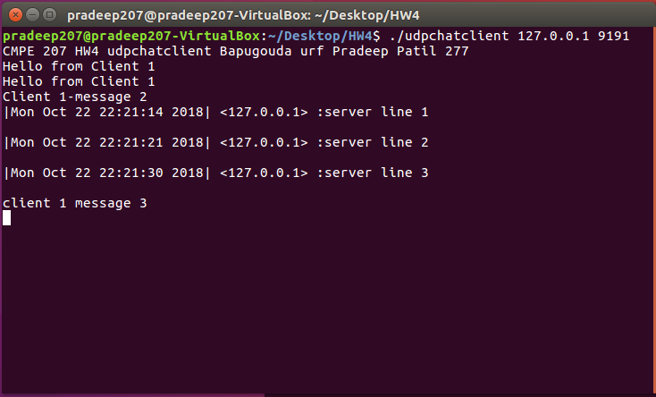

**VM2/client2 (both old and new client2)**

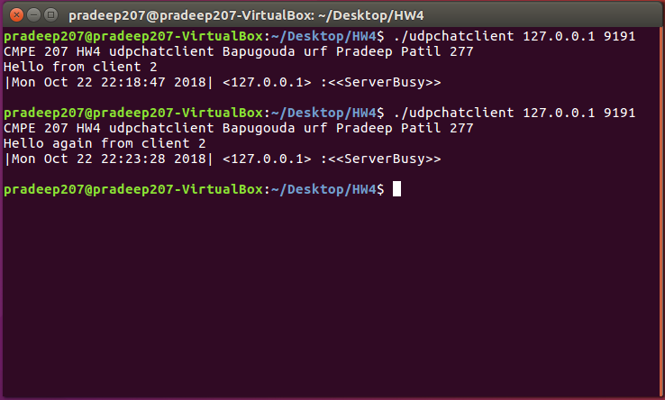

• VM1/server

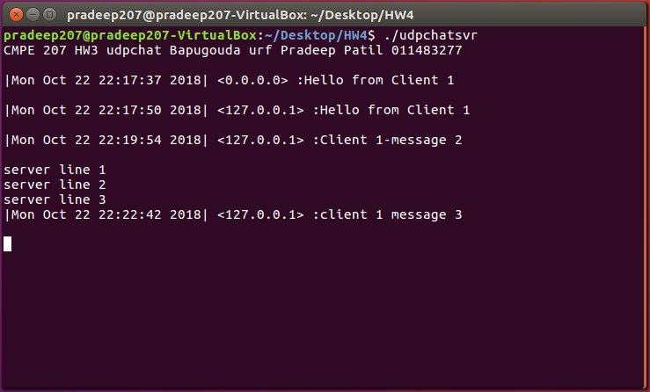

• VM1/other-shell

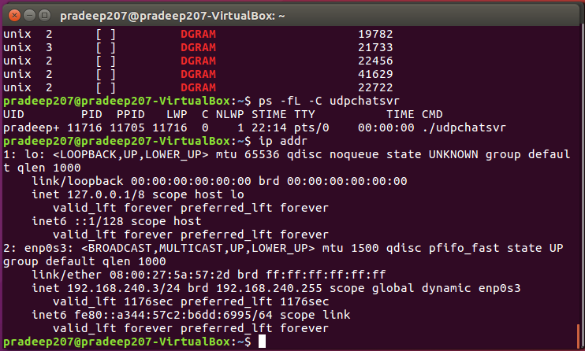

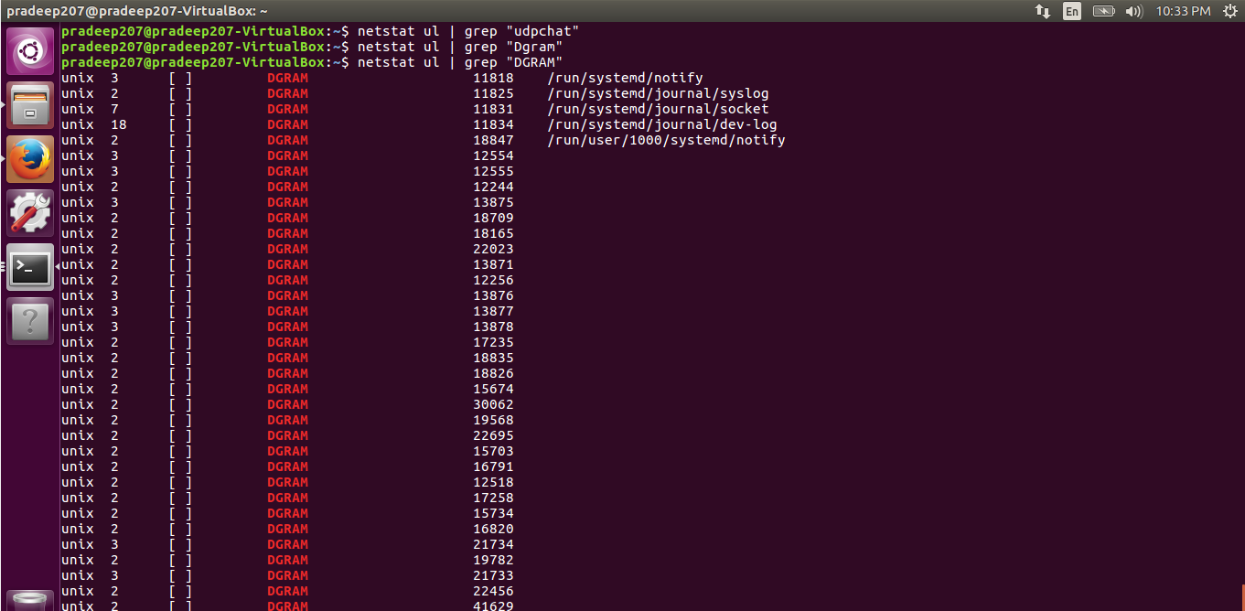

4. (10 pts) Given a UDP client on US west coast sends messages received by a UDP server on US east coast. UDP is unreliable and the packet can be lost on its way out (on client machine), lost in transit, and lost on its way in (on the server). For each of these three cases, give a specific scenario to illustrate why the UDP packet can be lost.

Answer:

**On its way out (on client machine):**

If the **socket send buffer** is lesser than the number of packets (UDP Packet) in the queue and the network card is slow and cannot handle huge traffic the packets are dropped by the operating system / kernel.

**lost in transit:**

**Congestion,** Hardware capacity and bottlenecks or faulty links may cause the packets to be dropped in the in the internet. This can happen at routers and nodes. Since UDP is connectionless no retransmission happens when a packet is lost or dropped.

**lost on its way in (on the server):**

A **socket receive buffer** carries the incoming packets on a machine, then the server application reads packets out of that buffer and handles them. If the server buffer gets full, the packets get dropped.